Our Class Charter
Oak

Our Rights | Our Responsibilities and Actions
 | -To help each other  -To use positive words  -To include people in our games and group work
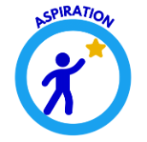 | -To concentrate on our task/activity  -To be resilient and keep trying  -To respond to feedback (make the suggested changes in our work).
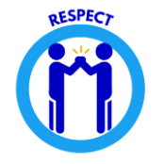 | -To use good manners  -To listen silently when others are talking  -To look at the person speaking  -To celebrate differences  -To use things and our environment sensibly
 | -To give new things a try  -To stand up for what is right  -When something is tricky, don’t give up.
To be safe  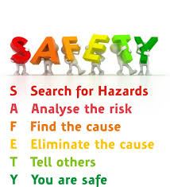 | - To follow our expected behaviours  - To stay with adults when we are out of the school premises  - To keep 4 chair legs on the floor  - To use equipment sensibly
Signed

