Our Class Charter
Sycamore Class


Our Rights | Our Responsibilities and Actions
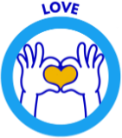 | - Check everyone is okay, especially if they are looking sad  - Forgive people if they have done something wrong  - Appreciate other people’s answers even if they are wrong  - If someone is having difficulty offer to help them  - Include everyone in our games and make new children feel welcome  - If someone gets hurt, offer to help them  - If someone is sad, comfort them  - Only say kind things to people. If we have unkind thoughts keep them to ourselves.
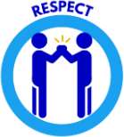 | - To listen and try not to fidget when someone is talking  - Respect other children whatever their ability  - Don’t touch other people’s belongings without permission  - Listen to others' ideas, even if we don’t agree with them  - Look after and treat the school’s resources with respect  - Appreciate other people’s answers even if they are wrong  - To keep our trays tidy
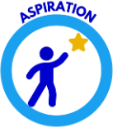 | - Always try our hardest  - Think that we are as good as anyone and can achieve anything  - Look at good role models and try to be like them  - To be the best version of myself I can be

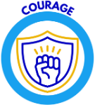 | - Ask for help, if I am unsure  - Be brave and don’t lie and try and get out of something  - Do the right thing even if others aren’t  - If someone isn’t saying or doing the right thing, tell an adult or ask them politely to stop  - Be brave and have a go at doing things
To be safe  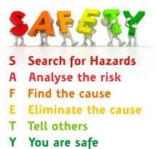 | - To walk around the classroom calmly  - To carry equipment safely  - To tuck our chairs under  - To close our locker doors  - If I don’t know what to do in an emergency ask for help

